The First Annual JCL

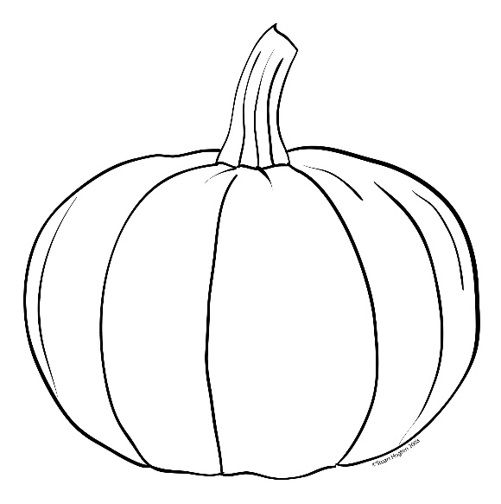Classical Pumpkin Prowl

From Friday to Monday THIS WEEK. Look for Pumpkins with themes form the Classical World in Chanel, Ivey, Centennial, and Admissions!