*Your Marist Latin Club presents…*

MT. VESUVIUS ­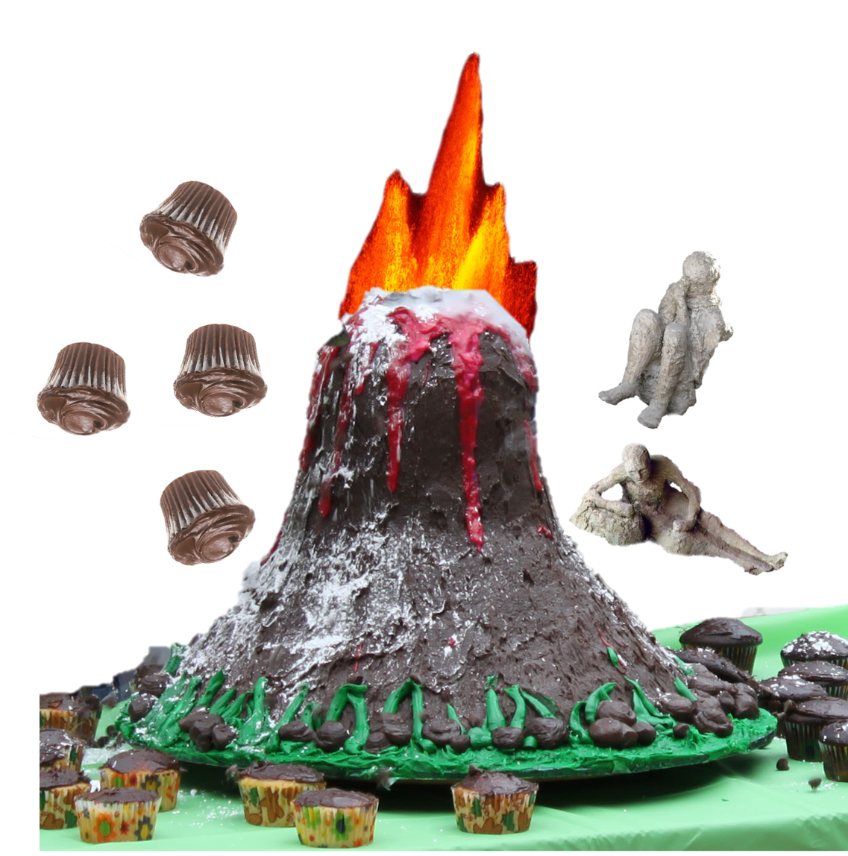



Come this Thursday, second half of Activity Period!

10:00, September 22, 2016