Aeneid Pumpkins

Pumpkin # 1

JUNO (aka Hera)

Juno is the goddess of marriage and family. She is the queen of all the Olympian gods, the wife of Jupiter (Zeus). Her favorite animal is the peacock. In the Aeneid, she is famous for being extremely angry at Aeneas, who is a Trojan.

Pumpkin Decorating Suggestions:

* Peacock theme
* Angry

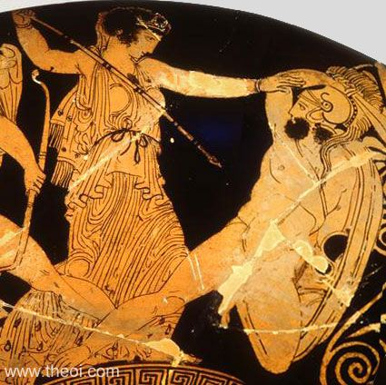 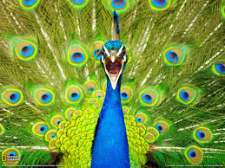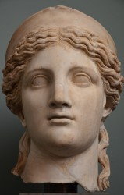

Aeneid Pumpkins

Pumpkin # 2

JUPITER (aka Zeus)

Jupiter is the king of all the gods, the husband of the Juno. He is the god of thunderstorms, and he is the ruler of the skies. His main weapon is the thunderbolt. In the Aeneid, he presides over all the gods and he favors Aeneas.

Pumpkin Decorating Suggestions

* Lightening theme
* Thunderstorms/Sky

 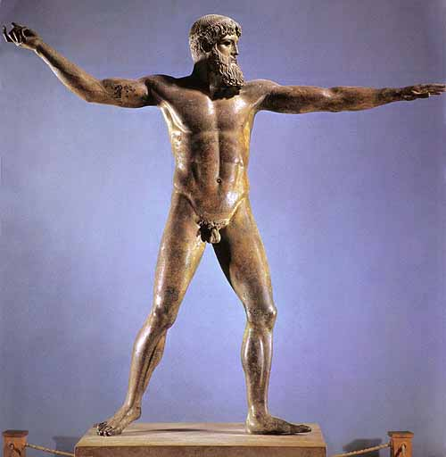

Aeneid Pumpkins

Pumpkin # 3

VENUS (aka Aphrodite)

Venus is the goddess of beauty and love. She is the most beautiful goddess, and is married to the god of the forge, Vulcan (Hephaestus). She is the mother of Aeneas, and therefore acts as a protector for him throughout the Aeneid.

Pumpkin Decorating Suggestions

* Beauty theme

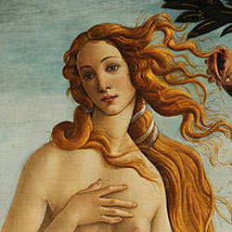 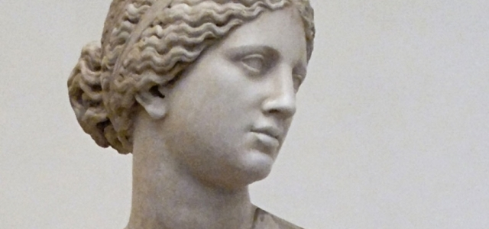

Aeneid Pumpkins

Pumpkin # 4

POLYPHEMUS

Polyphemus is one of the Cyclopes, huge, hulking giants with only one eye. While Polyphemus is famous for his encounter with Odysseus, the hero of the Odyssey, the Cyclopes also makes an appearance in the Aeneid.

Pumpkin Decorating Ideas

* One Eyed Monster

